“**Railway Enquiry System”**

**A PROJECT REPORT**

Submitted By:

Amarjeet Singh (161B027)

Amit Kumar (161B028)

Satyam Prakash (161B201)

Under the Guidance of: Mr. Neelesh Kumar Jain

November – 2018

Submitted in partial fulfillment of the Degree of

BACHELOR OF TECHNOLOGY

IN

COMPUTER SCIENCE & ENGINEERING

**Department of Computer Science & Engineering**

JAYPEE UNIVERSITY OF ENGINEERING & TECHNOLOGY,A-B ROAD, RAGHOGARH, DT. GUNA - 473226, M.P., INDIA

**Declaration by the Student**

I hereby declare that the work reported in the B. Tech. project entitled as “**Railway Enquiry System**”, in partial fulfillment for the award of degree of B. Tech. submitted at Jaypee University of Engineering and Technology, Guna, as per best of my knowledge and belief there is no infringement of intellectual property right and copyright. In case of any violation I will solely be responsible.

Amarjeet Singh (161B027)

Amit Kumar (161B028)

Satyam Prakash (161B201)

Department of Computer Science and Engineering

Jaypee University of Engineering and Technology

Guna, M.P., India.

Date: /1 /2018.

**CERTIFICATE**

This is to certify that the work titled “**Railway Enquiry System**” submitted by “**Amarjeet Singh (161B027), Amit Kumar (161B028), Satyam Prakash (161B201)**” in partial fulfillment for the award of degree of B. Tech. of Jaypee University of Engineering & Technology, Guna has been carried out under my supervision. As per best of my knowledge and belief there is no infringement of intellectual property right and copyright. Also, this work has not been submitted partially or wholly to any other University or Institute for the award of this or any other degree or diploma. In case of any violation concern student will solely be responsible.

Mr. Neelesh Kumar Jain

Asst. Professor(G-II)

Date: /1 /2018

**ACKNOWLEDGEMENT**

A study or a project of this volume can never be the outcome of a single person or just a mere group of dedicated students, so we express our profound sense of gratitude to those who extended their whole hearted help and support to us in completing our project because successful completion of any work requires guidance and help from a number of people.

Firstly, it gives us immense pleasure to acknowledge our institute **Jaypee University of Engineering & Technology** for providing us an opportunity in developing a project on **Railway Enquiry System.**

In addition, we wish to express our deep sense of gratitude to **Mr. Neelesh Kumar Jain, Assistant Professor** for permitting us to carry out this project work and for his guidance and support.

(Amarjeet Singh) (Amit Kumar) (Satyam Prakash Pandey)

Date : /11/2018

*************

**ABSTRACT**

This project introduces National Train Enquiry System (NTES). It explains how user can check as well as enquire about the certain railway’s features such as PNR status, Train availability etc. in Indian Railways. The systematic procedure is explained. This project is developed using HTML, CSS, Bootstrap, Javascript, AJAX etc. languages. All the required features of these languages are used in this project. Proper comments have been given at desired locations to make the project user friendly.

The users are required to enter the PNR number of 10 digits to get the PNR status, get the info about train availability by entering the train number (5) of particular train, get the info about train route by entering the train number (5) of particular train, to get the information about the seat availability enter Train number, Source Station, Destination Station, Date at which train runs, to get the information about the live status of the train enter Train number, Source Station and date, to get the information about the cancelled trains user have to enter only current date, to get the information about the diverted trains user have to enter only current date, to get the information about the fare user have to enter Train number, destination station, age, preference, quota and date, to get the information about the train between station user have to enter Source Station, Destination Station and Date, to get the information about the Station autocomplete suggest user have to enter Name of enquired Station, to get the information about the Train Autocomplete suggest user have to enter Train Number.

This project is dedicated to model the existing NTES that aims at development of NTES that facilitates the railway users to enquire the above mentioned functions in a user-friendly manner.

*************

**TABLE OF CONTENT**

**TITLE**______________________________________________________________________ 1

**DECLARATION _____________________________________________________________2**

**CERTIFICATE** ______________________________________________________________ 3

**ACKNOWLEDGEMENT** _____________________________________________________ 4

**ABSTRACT**_________________________________________________________________ 5

**LIST OF FIGURES**___________________________________________________________ 6

**CHAPTER 1. INTRODUCTION** ________________________________________________9

1.1. Objective...................................................................................................................... 9

1.2. History........................................................................................................................ 10

1.3. Brief............................................................................................................................11

1.4. Advantage of RES...................................................................................................... 12

1.5. Proposed System........................................................................................................ 12

**CHAPTER 2. PROJECT PLANNING__________________________________________ 13**

2.1. Identification of Need.................................................................................................13

2.2. UI Design....................................................................................................................13

2.3. Reports of Railway Enquiry System………………………………………………...14

2.4. System design of RES................................................................................................ 15

2.5. Feasibility Study.........................................................................................................16

2.6. Project Planning..........................................................................................................17

**CHAPTER 3.TECHNOLOGY AND TOOLS_____________________________________19**

**CHAPTER 4. SOFTWARE REQUIREMENT SPECIFICATION___________________ 20**

4.1. Inroduction…............................................................................................................. 20

4.1.1. Purpose........................................................................................................ 21

4.1.2. Scope ………………….............................................................................. 22

4.1.3. Reference ....................................................................................................22

4.1.4. Definition Acronyms and Abbrevation....................................................... 22

4.1.5. Overview..................................................................................................... 22

4.2. The Overall Description............................................................................................. 23

4.2.1 Product Perspective…...................................................................................23

4.2.1.1 System Interface….........................................................................24

4.2.1.2 Hardware Interface.........................................................................25

4.2.1.3 Software Interface..........................................................................25

4.2.1.4 Communication Interface...............................................................25

4.2.2.User Characterstic….....................................................................................25

4.2.3. Constraints ................................................................................................. 25

4.3. Specific Requirements…………………...………………………………………….26

4.3.1. External Interface………........................................................................... 26

4.3.2 Performance Requirements…..................................................................... 26

4.3.3. Software System Attributes........................................................................ 27

4.3.4. Functional Requirements.............................................................................27

4.3.5. Non- Functional Requirements……........................................................... 28

**CHAPTER 5. DIAGRAMS____________________________________________________ 29**

5.1. Use Case......................................................................................................................29

5.2.DFD…………….........................................................................................................30

5.2.1 DFD Level 0 ……........................................................................................30

5.2.2. DFD Level 1 .............................................................................................. 31

5.3. ER Diagram................................................................................................................32

5.4. Sequence Diagram……..............................................................................................33

5.5. Activity Diagram……................................................................................................34

5.6. PERT Chart............................................................................................................... 35

5.7. Gantt Chart................................................................................................................ 36

**CHAPTER 6. PROJECT FUNCTIONS_________________________________________ 37**

6.1. General overview of application…….........................................................................37

**CHAPTER 7. CONCLUSION** _________________________________________________ 45

**CHAPTER 8. LIMITATION**__________________________________________________ 46

**CHAPTER 9. FUTURE SCOPE**_______________________________________________ 47

**CHAPTER 10. BIBLIOGRAPHY** _____________________________________________ 48

**List Of Figures:**

|  |  |  |  |
| --- | --- | --- | --- |
| **S.NO.** | **Name Of Figure** | **Figure Number** | **Page No.** |
| **1** | Use Case Diagram | Fig.5.1 | 29 |
| **2** | DFD (level 0) | Fig.5.2 (I) | 30 |
|  | DFD (level 1) | Fig.5.2 (II) | 31 |
| **3** | E R Diagram | Fig.5.3 | 32 |
| **4** | Sequence Diagram | Fig.5.4 | 33 |
| **5** | Activity Diagram | Fig.5.5 | 34 |
| **6** | PERT Chart | Fig.5.6 | 35 |
| **7** | GANTT Chart | Fig.5.7 | 36 |
| **8** | PNR Status | Fig.6.1 |  |
| **9** | Train Availability | Fig.6.2 |  |
| **10** | Train Route | Fig.6.3 |  |
| **11** | Seat Availability | Fig.6.4 |  |
| **12** | Fare Enquiry | Fig.6.5 |  |
| **13** | Live Status | Fig.6.6 |  |
| **14** | Cancelled Trains | Fig.6.7 |  |
| **15** | Rescheduled Trains | Fig.6.8 |  |

**LIST OF ACRONYMS:**

|  |  |  |
| --- | --- | --- |
| 1 | HTML | Hyper Text Markup Language |
| 2 | CSS | Cascading Style Sheet |
| 3 | JS | JavaScript |
| 4 | NTES | National Train Enquiry System |
| 5 | AJAX | Asynchronous JavaScript and XML |
| 6 | JSON | JavaScript Object Notation |
| 7 | DFD | Data Flow Diagram |
| 8 | RES | Railway Enquiry System |

**CHAPTER-1 : INTRODUCTION**

**Objective:**

Our project introduces railway enquiry system with an objective to make the enquiry system more efficient and easier. This project explores how computer technology can be used to solve the problem of user.

The main objectives provided by this software are as follows:

* We can enquire about availability of trains.
* We can enquire about PNR Status of passengers
* We can enquire about the route of a train
* We can enquire about the live Status of the trains.
* We can enquire about the Rescheduled trains.
* We can enquire about Fare of Train between two stations
* We can enquire about the trains between two stations on a particular date.

facilitates the railway customer to manage their reservations and the railway administrator to modify the backend database in a user-friendly manner.

**History:**

**Indian Railways** (**IR**) is India’s national railway system operated by the ministry of Railways. It manages the 4th largest railway network in the world by size, with 121,407 kilometers (75,439 mi) of total track over a 67,368-kilometre (41,861 mi) route. Forty nine percent of the routes are electrified with 25 KV electric traction while thirty three percent of them are double or multi-tracked.

IR runs more than 20,000 passenger trains daily, on both long-distance and sub-bourbon routes, from 7,349 stations across India. The trains have a five-digit numbering system. Mail or express trains, the most common types, run at an average speed of 50.6 kilometers per hour (31.4 mph). In the freight segment, IR runs more than 9,200 trains daily. The average speed of freight trains is around 24 kilometers per hour (15 mph).

As of March 2017, IR's rolling stock consisted of 277,987 freight, 70,937 passenger coaches and 11,452 locomotives. IR owns locomotive and coach-production facilities at several locations in India. The world's eighth-largest employer, it had 1.308 million employees as of March 2017.

In the year ending March 2018, IR carried 8.26 billion passengers and transported 1.16 billion tons of freight. In the fiscal year 2017-18, IR is projected to have revenue of ₹1.874 trillion (US$26 billion), consisting of ₹1.175 trillion (US$16 billion) in freight revenue and ₹501.25 billion (US$7.0 billion) in passenger revenue, with an operating ratio of 96.0 percent.

**BRIEF:**

In this emerging world of computers, almost all-manual system has switched to automated and computerized system. Therefore, we are developing the software for “Railway Enquiry System” to model the present system. This project explores how computer technology can be used to solve the problem of user.

This being a big step in terms of improvement in the railway system it is widely accepted across the country. Rather than designing manually, we have made use of computer. Use of computer has solved many problems, which are faced during manual calculation. Once data are fed, it can perform accurate functions. Therefore, to reduce the complexity and efficiency a versatile and an outsourcing railway reservation system has been developed.

This project introduces National Train Enquiry System (NTES). It explains how user can check as well as enquire about the certain railway’s features such as PNR status, Train availability etc. in Indian Railways. The systematic procedure is explained. This project is developed using HTML, CSS, Bootstrap, Javascript, AJAX etc. languages. All the required features of these languages are used in this project. Proper comments have been given at desired locations to make the project user friendly.

The users are required to enter the PNR number of 10 digits to get the PNR status, get the info about train availability by entering the train number (of 5 Digits) of particular train, get the info about train route by entering the train number (of 5 Digits) of particular train, to get the information about the seat availability enter Train number, Source Station(in strings), Destination Station(in strings), Date(date in IST) at which train runs, to get the information about the fare you have to enter source station(in strings),destination station(in strings),date (date in IST),quota (like General , like SL, like Ac (III), Ac (II),AC(I)) , to get the list of trains in between two station user have to enter Source station(in strings),Destination Source(in strings),date(date in IST), to get the information about the live status of the train enter Train number((of 5 Digits)), Source Station (in strings)and date(date in IST), to get the information about the cancelled trains user have to enter only current date(date in IST), to get the information about the diverted trains user have to enter only current date.

This project is dedicated to model the existing NTES that aims at development of NTES that facilitates the railway users to enquire the above mentioned functions in a user-friendly manner. The customer and the railway administrator are two parties that interact with the database, who have different ‘view level schemas’ to the database information. The software provides a comprehensive set of features to enhance the operational limits.

**ADVANTAGE OF RAILWAY ENQUIRY SYSTEM**

Now one can easily plan the journey comfortably as the process is efficient and fast with being easy to access. Train related enquiry can be made through the National train enquiry system or at the ample reservation centers all over the country. E-services of railway is the big boost for the railway because people are less tensed because they don't have to suffer for the long queues or rude behavior of the staffs ,and they can reserve the ticket in their halls, and government try to publish as much as they can to draw attention of passengers to these sites.

**PROPOSED SYSTEM**

Today one cannot afford to rely on the fallible human beings of be really wants to stand against today's merciless competition where not to wise saying "to err is human" no longer valid, it's outdated to rationalize your mistake. So, to keep pace with time, to bring about the best result without malfunctioning and greater efficiency so to replace the unending heaps of flies with a much sophisticated hard disk of the computer. One has to use the data management software. Software has been an ascent in atomization various organizations. Many software products working are now in markets, which have helped in making the organizations work easier and efficiently. Data management initially had to maintain a lot of ledgers and a lot of paper work has to be done but now software product on this organization has made their work faster and easier. Now only this software has to be loaded on the computer and work can be done.

This prevents a lot of time and money. The Work becomes fully automated and any information regarding the organization can be obtained by clicking the button.

Moreover, now it's an age of computers of and automating such an organization gives the better look.

**Project Planning**

**Identifaction of need:**

The old manual system is still existing in indian railway and there are improvement in the railway but still there is only one official website called NTES but in the website there are functions to check about certain functions but we extended the website and added some more function in that so people don't have to visit multiple websites to get information .this is an extended version of ntes and in this we can access information about multiple things about trains,stations and timetable about trains.

**Followings points should be well considered:**

* Documents and reports that must be rovided by the new system; there can also be few reports ,which can help management in decision-making and cost controliong,but since these reports do not get required attention,such kind of reports and information were also identified and given required attention.
* With the implementation of computerized system, the task of keeping records in an organized manner will be solved. The greatest of all is the retrival of information,which will at the click of the mouse.so the proposed system helps in saving the time in different operations and making information flow easy giving valuable reports.

**User Interface Design:**

User Interface Design is concerned with the dialogue between a user and the computer .It is concerned with everything from starting the system on web browser to the presentation of desired inputs and outputs.The overall flow of screens and messages is called a dialogue.

**The followings steps are various guidelines for user interface design:**

* The system user should always be aware of what to do next.
* The screen should be formatted so that various types of information,instructions and messages always appear in the same general display area.
* Message ,instruction or information should be displayed long enough to allow the system user to read them.
* Use display attributes sparingly.
* Default values for fields and answers to be entered by the user should be specified.
* A user should not be allowed to proceed without correcting an error.

**Reports of Railway Enquiry System:**

* It generate the report of train with entering the train number in numbers.
* It generate pnr status of reserved tickets and pnr no. Must be in numbers and length of the number is 10.
* it generate the live status by entering the required fields.
* It generate the cancelled train and rescheduled by entering the date.

**Modules Of Railway Enquiry System**

* Train Schedule Module
* Train Route Module
* Ticket Module
* Train Fare Module

**The Software Quality Plan:**

* In the first step ,we will select the test factors and rank them. The Selected test factors such as reliability ,maintainability,portability or etc.
* The second step is for identifying the phases of the development process.
* The third step is that identifying the bussiness risks of the software deliverables.The risks will be ranked into three ranks such as high ,medium and low.

**System Design of railway enquiry system**

In this phase, a logical system is built which fulfills the given requirements. Design phase of software development deals with transforming the client’s requirements into a logically working system. Normally, design is performed in following two steps:

**1: Primary Design phase:** In this phase, the system is designed at block level. The blocks are created on the basis of analysis done in problem identification phase. Different blocks are created for different functions emphasis is put on minimizing the information flow between blocks. Thus, all activities which require more interaction are kept in one block.

**2: Secondary Design phase:**

In secondary phase the detailed design of every block is performed.

**The general tasks involved in the design process are the following:**

1. Design various blocks for overall system process.
2. Design smaller, compact and workable modules in each block.
3. Specify details of programs to achieve desired functionality.
4. Design the form of inputs, and outputs of the system.
5. Perform documentation of the design.
6. System reviews.

**Feasibility Study**

After doing the project Railway Enquiry System, study an analyzing all the existing or required functionalities of the system, the next task is to do the feasibility study for the project. All projects are feasible- given unlimited resource and infinite time.

Feasibility study includes consideration of all the possible ways to provide a solution to the given problem. The Proposed solution should satisfy all the user requirements and should be flexible enough so that future changes can be easily done based on the future upcoming requirements.

1. **ECONOMICAL FEASIBILITY**

This is a very important aspect to be considered while developing a project .We decided the technology based on minimum possible cost factor.

* All hardware and software aspect to be considered while developing a project. We decided the technology based on minimum possible cost factor.

B. **Technical Feasibility**

This include the study of function, performance and constraints that may affect the ability to achieve an acceptable system. For this feasibility study, we studied complete functionality to be provided in the system, as described in the system Requirement Specification, and checked if everything was possible using different type of frontend and backend platform.

C**. OPERATIONAL FEASIBILITY**

No doubt the proposed system us fully web based system as well as mobile based too and user friendly and al inputs to be taken all self-explanatory even to a layman. Beside, a proper training has been conducted to let know the essence of the system to the users so they feel comfortable with new system.

**Project planning:**

Software project plan can be viewed as following:

1. **Within the Group:** Ho the project is to be implemented? What are various constraints (time, cost and staff)? What is market strategy?
2. With respect to the customer: we have to look in as customers and try to improve services as they demand and try to solve the problem as they give feedback and then give it to them.

**For a successful software project, the following steps can be followed:**

* Select a project
* Identifying Project's aims and objectives
* Understanding requirements and specification
* Methods of analysis , design and implementation
* Testing Techniques
* Documentation
* Project milestones and deliverables
* Budget allocation
* Exceeding limits within control
* Project Estimates
* Cost
* Time
* Size of code
* Duration
* Resource Allocation
* Hardware
* Software
* Previous relevant project information
* Digital Library
* Risk Management
* Risk avoidance
* Risk detection

**TECHNOLOGY (TOOLS AND CONTENTS)**

**Platform Used:**

1. **Hardware Platform:**

* System Model : HP Pavilion
* Processor : Intel CORE 'i3'
* RAM : 4 GB
* Hard disk : 512 GB

**2. Software Platform:**

* Operating System : Windows 10
* Compiler : Bracket ,Google Chrome
* Editor : Sublime Text, Bracket

**SOFTWARE REQUIREMENT SPECIFICATION**

A Software Requirement Specification (SRS) is a requirements specification for a software system that is a complete description of the behavior of a system to be developed. It includes a set of use-cases that describe all the interactions the users will have with the software. Use cases are also known as functional requirements. In addition to use cases, the SRS also contains non-functional (or supplementary) requirements. Non-functional requirements are requirements that impose constraints on the design or implementation (such as performance engineering requirements, quality standards, or design constraints).

The initial specifications of user requirements may be based on interviews with the database users and on the designers own analysis of the enterprise. The basic issues that the SRS writer(s) shall address are the following:

* **Functionality:**

What is the software supposed to do?

* **External interfaces.**

How does the software interact with people, the system’s hardware?

Other hardware, and other software?

* **Performance**

What is the speed, availability, response time, recovery time of various?

Software functions, etc. ?

* **Attributes**

What is the portability, correctness, maintainability, security, etc. considerations?

An SRS should be:

1. Correctness
2. Unambiguous
3. Complete
4. Consistent
5. Ranked for importance and/or stability
6. Verifiable
7. Modifiable
8. Traceable

**1. INTRODUCTION:**

**1.1. PURPOSE:**

The purpose of this software is to describe the National train Enquiry System which provides the PNR Status Train Availability Train route seat availability Live status and cancellation on various types of Trains namely:-

* Checking the PNR Status.
* Checking the Train Availability of a train.
* Checking the Train Route of a train.
* Checking the Seat Availability of trains.
* Checking the fare enquiry of trains between two stations.
* Checking the trains between two stations on a particular date.
* Checking the live status of trains.
* Checking the cancelled trains.
* Checking the rescheduled trains.
* Getting the full name of the station.
* Getting the full train name.

**1.2. SCOPE:**

The scope of this project is limited to an engineering college. This project aims to maintain passenger and train information.

Other scopes of this project are as follows:

* Freight Revenue enhancement
* Passenger Revenue enhancement
* Improved and optimized service

**1.3. REFERENCES:**

* www.irctc.com
* www.indiarail.com
* www.enquiry.indianrail.gov.in
* www.w3school.com
* www.railwayapi.com

**1.4. DEFINITIONS, ACRONYMS AND ABBREVIATIONS**

* NTES : National Train Enquiry System
* IR : Indian Railway

**1.5. OVERVIEW:**

This project aims at development of a Railway Enquiry System that facilitates the Railway customers in enquiring the various services and the Railway administrators to modify the backend databases in a User-Friendly manner.

**2. THE OVERALL DESCRIPTION:**

**2.1. PRODUCT PERSPECTIVE:**

It enables us to maintain the railway train details like their timings, number of seat available, PNR status, live status, cancelled train status and rescheduled train status.

**PNR status:**

After entering the PNR number user easily check whether their seats are confirmed or in waiting list.

**Train Availability:**

After entering the train number user can check o which day train is available for travelling.

**Train Route**:

After entering the train no. user can check the route of the trains and according to that they can plan their journey.

**Seat Availability:**

After entering the required information you can check whether seat is available on the train or not and according to that people can plan their journey.

**Fare Enquiry :**

After entering all the required information in the correct format then it shows the fare between two stations.

**Train between Two Station :**

After entering source station name and destination station name and date user can get the list of trains which are available on that day

**Live Status:**

This is the most important aspects of train because it helps user in many ways and after entering the required fields you can get the live status of the train.

**Cancelled Train:**

This is also a must features for the passengers to know that on particular day the train is cancelled or not after entering the date user can easily access the list of the cancelled trains.

**Reschedule Train:**

After entering the date you can get the train’s lists which are diverted to other routes.

**2.1.1 System Interface:**

In this phase, a logical system is built which fulfills the given requirements. Design phase of software development deals with transforming the client’s requirements into a logically working system. Normally, design is performed in following two steps:

**1: Primary phase:**

In this phase, the system is designed at block level. The blocks are created on the basis of analysis done in problem identification phase. Different blocks are created for different functions emphasis is put on minimizing the information flow between blocks. Thus, all activities which require more interaction are kept in one block.

**2: Secondary phase:**

In secondary phase the detailed design of every block is performed.

**The general tasks involved in the design process are the following:**

1. Design various blocks for overall system process.
2. Design smaller, compact and workable modules in each block.
3. Specify details of programs to achieve desired functionality.
4. Design the form of inputs, and outputs of the system.
5. Perform documentation of the design.
6. System reviews.

**2.2.2. Hardware Interface:**

* System Model : HP Pavilion
* Processor : Intel CORE 'i3'
* RAM : 4 GB
* Hard disk : 512 GB
  + 1. **Software Interface:**
* Operating System : Windows 10
* Compiler : Bracket ,Google Chrome
* Editor : Sublime Text, Bracket

**2.1.5 Communication Interface :** None

**2.2. USER CHARACTERISTICS:**

* Knowledgeable User
* Novice User
* Expert User

**2.3. CONSTRAINTS:**

There is no maintainability of back up so availability will get affected. Real-life credit card validation and Banking system is not implemented. No multilingual support. Given below is an overall picture of the system, as depicted in the above.

**Administrator:**

**Database Management:**

* Control the database of trains and keep track of all records of train.
* View the details of all orders and control the whole application

**Customers:**

* Customers can enter all the required fields to get the details about the trains.

**3. SPECIFIC REQUIREMENTS:**

**3.1. EXTERNAL INTERFACES:**

* Enquiry Terminals

**3.2. PERFORMANCE REQUIREMENTS:**

It’s available during all 24 hours.

Variety of compartments based on comfort:

* AC
* Non-AC
* General

Types of concerns and complexities:

* 10 types of trains
* 3 types of classes

**3.3. SOFTWARE SYSTEM ATTRIBUTES:**

* Reliable
* Available
* Secure
* Portable

**3.4. FUNCTIONAL REQUIREMENTS:**

In software engineering, a functional requirement defines a function of a software-system or component. A function is described as a set of inputs, the behavior and outputs. Functional requirements may be calculations, technical details, data manipulation and processing and other specific functionality that show how a use case to be fulfilled. Typically, a requirements analyst generates functional requirements after building use cases. However, this may have exceptions since software development is an iterative process and sometime certain requirements are conceived prior to the definition of the use case. Both artifacts (use cases documents and requirements documents) complement each other in a bidirectional process. Atypical functional requirement will contain a unique name and number, a brief summary, and a rationale. This information is used to help the reader understand why the requirement is needed, and to track the requirement through the development of the system. The core of the requirement is the description of the required behavior, which must be a clear and readable description of the required behavior. This behavior may come from organizational or business rule, or it may be discovered through elicitation sessions with users, stake holders and other experts within the organization. Software requirements must be clear, correct unambiguous, specific and verifiable.

**3.5. NON-FUNCTIONAL REQUIREMENTS:**

In systems engineering and requirements engineering, non-functional requirements are requirements that specify criteria that can be used to judge the operation of system, rather than specific behaviors. Non-functional requirements are often called qualities of a system. Other terms for non-functional requirements are “constraints”, ”quality attributes”, “quality goals” and “quality of service requirements” .

Qualities, i.e. non-functional requirements can be divided into 2 main categories:

1. Execution qualities such as security and usability are observable at run time.
2. Evolution qualifies, such as extensibility and scalability embody in the static structure of the software system.

**The Non-Functional requirements of our project are:**

* **Time:**

This project should be completed within the stimulated time period.

* **Cost:**

The cost involved in marketing the project should be less.

* **Usability:**

This requirement is present, as this system will interact with the user.

* **Reliability:**

This system must be highly robust.

* **Performance:**

It should be fast enough to produce output.

**Diagrams**

There has been continous effort to develop tools,which can ease the process of software development.But with the evolving trend of diffrent programing paradigms today's software developers are really challenged to deal with the changing technology.This project makes a novel attempt to address the issued of program analysis and generation of diagrams,which can be depictthe structure of a program in a better way. Today UML is being considered as an industrial standard for software engineering design process. It essential provides several diagramming tools that can express diffrent aspects of programs such as

**Use Case**:Elicit requirement from users in meaningful chunks ,construction planning is built arround delievring some use cases in each interaction basis for system testing.

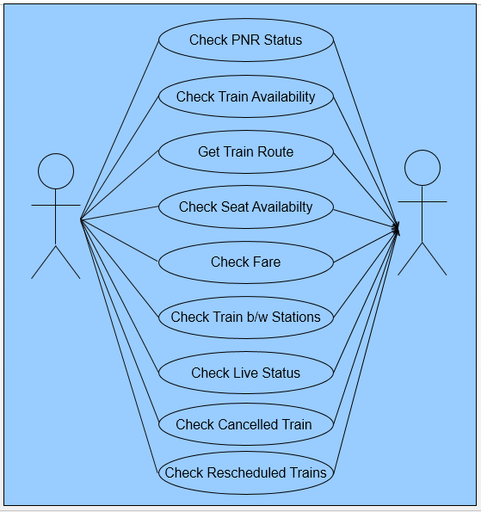

**DFD (Data Flow Diagram):**

A **data flow diagram** (**DFD**) is a graphical representation of the "flow" of data through an information system, modelling its process aspects. A **DFD** is often used as a preliminary step to create an overview of the system without going into great detail, which can later be elaborated.

**DFD (Level 0):**

A level 0 data flow diagram (DFD), also known as a context diagram, shows a data system as a whole and emphasizes the way it interacts with external entities.

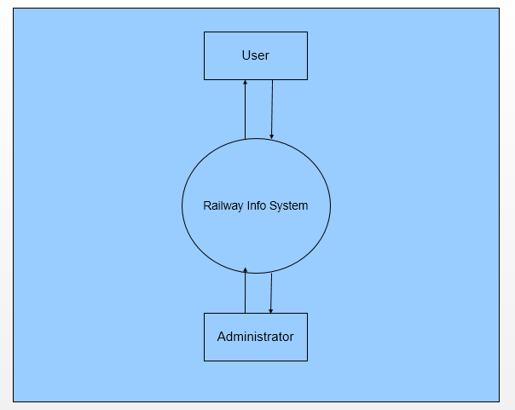

**DFD (Level 1):**

A level 1 data flow diagram (DFD) is more detailed than a level 0 DFD but not as detailed as a level 2 DFD.

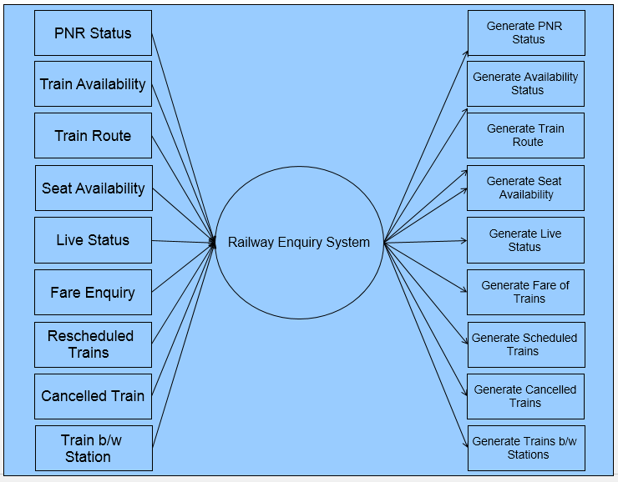

**ER (Entity Relationship) Diagram:**

 An entity in this context is an object, a component of data. An entity set is a collection of similar entities. These entities can have attributes that define its properties.

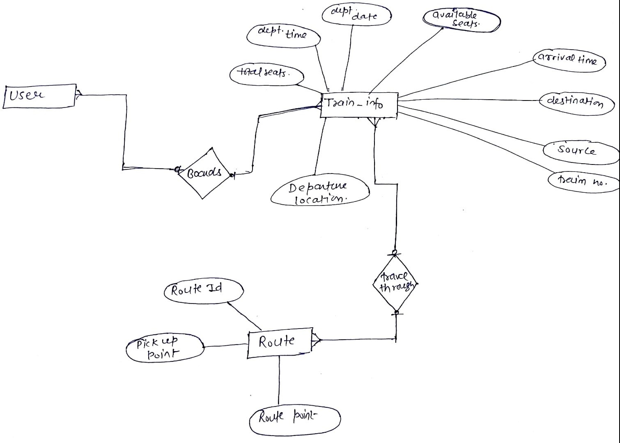

**Sequence Diagram**: In software engineering, a system sequence diagram (**SSD**) is a sequence diagram that shows, for a particular scenario of a use case, the events that external actors generate, their order, and possible inter-system events.

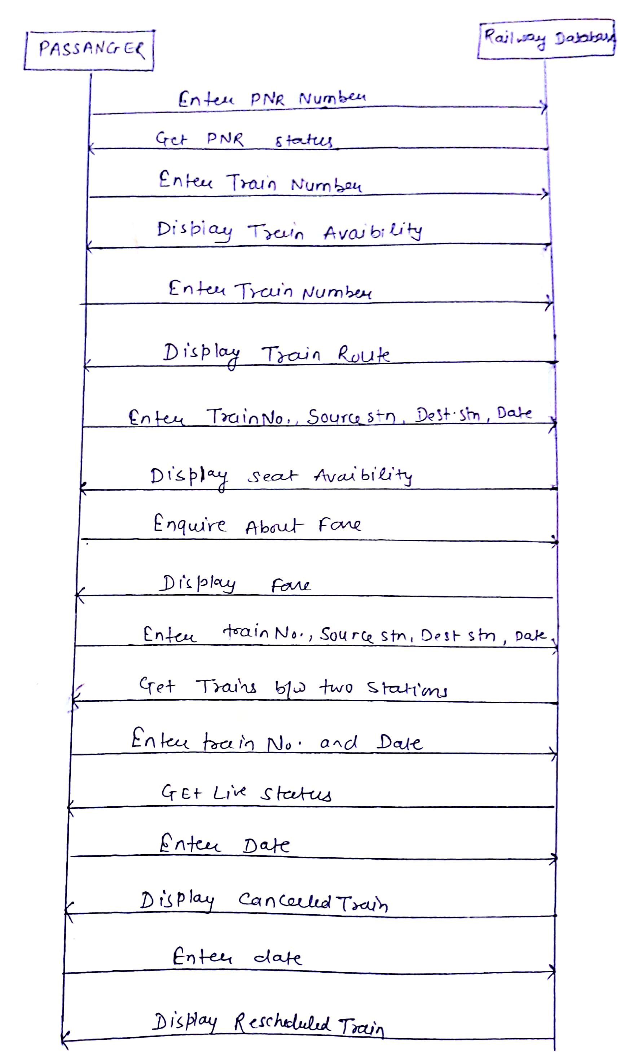

**Activity Diagram**:

Shows behaviour with control structure .Can show many objects over many uses ,many objects in single use case ,or implementations methods encourage parllel behavior etc.

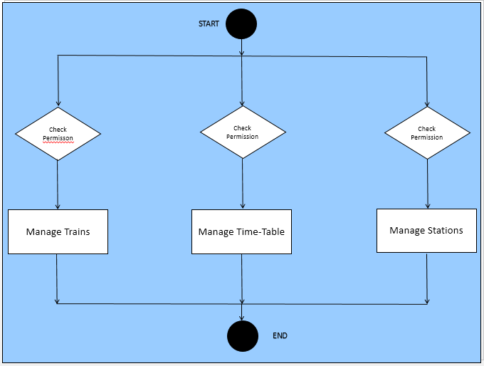

**PERT Chart (Program Evaluation Review Technique):**

PERT chartis organized for events ,activities or tasks .it is a scheduling device that shows graphically the order of the tasks to be performed.

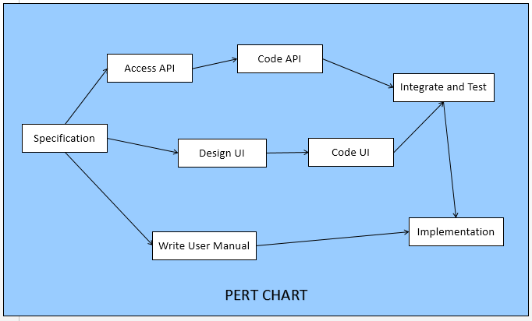

**Gantt Chart:**

It is also known as bar chart is used exclusively for scheduling purpose.It is a project controlling technique.it is used for scheduling,Budgeting and resourcing planning.A Gantt is a bar chart with each bar representing activity.The bars are drawn against a timeline. The length of time planned for the activity.

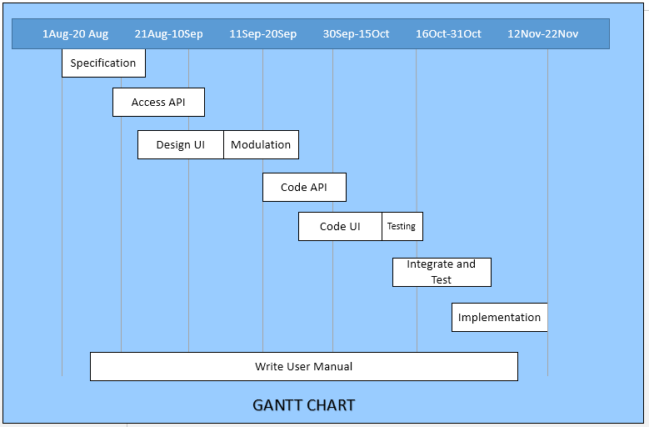

**About Project:**

**General Overview of Project:**

PNR Status

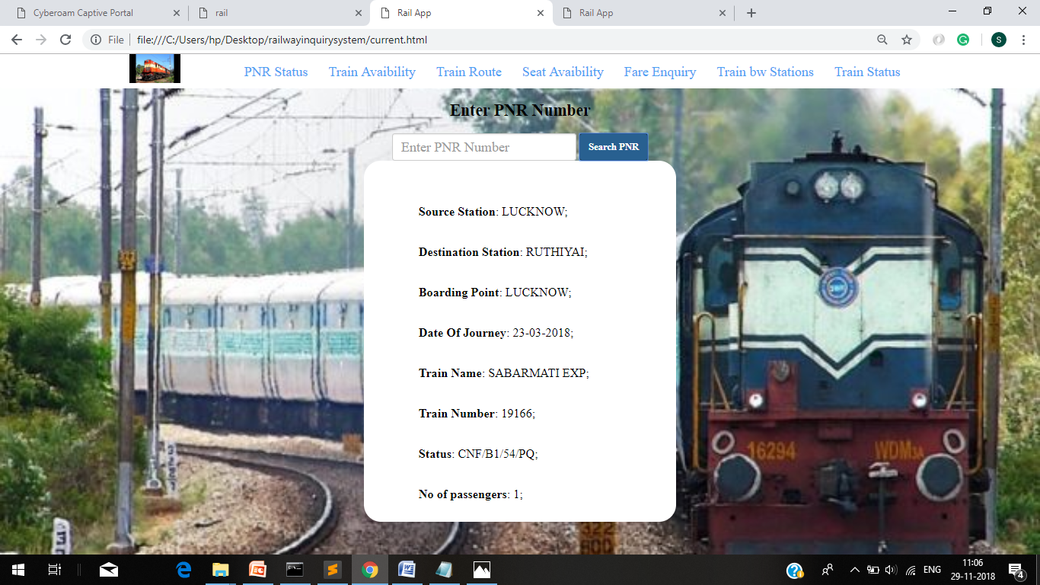

Fig 6.1

Indian Railways, is the fourth largest railway network in the world. So, To make our journeys easier and memorable, this app will help us to track PNR statuses, at the click of a button. To track Live PNR Status, we just have to enter our PNR number on the search bar of the page. It will then reflect the PNR status of our ticket. PNR stands for Passenger Name Record.

You can find PNR status at the top of the tickets and this number helps to confirm the status of your ticket whether it lied in waiting list or is confirmed. In case it has not been confirmed, it is through this number only that you will get the refunds from Railways and try for other means of transport. The main reason of implementing the PNR status systems is better management of passengers on regular basis. It has also empowered the Railways to perform better and become convenient or passengers as well.

Train Availability

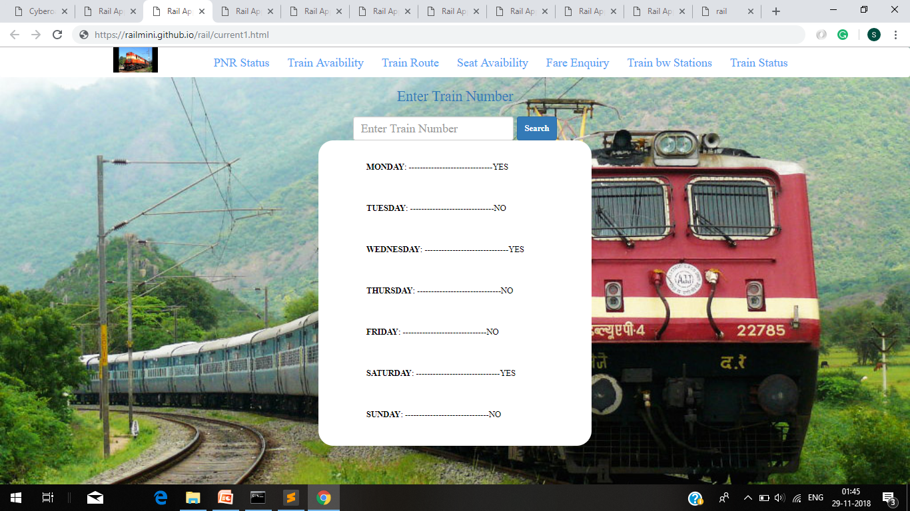

Fig 6.2

With train availability one can know about the days on which a train runs just by entering the train number. For example if a train runs on a particular day then it will tell YES, else it will tell NO. The services offered by this app are in real time and detailed. A train journey through the scenic terrains of India holds the fancy of most people. Coupled with affordable fares, trains are undoubtedly the prime choice of travel for the majority of Indian population. No wonder then that Indian Railways Train availability is always fraught with stress and confusion.

Thankfully, with the advanced reservations of railway tickets for trains opening at least 4 months prior to the journey, most people can now plan their trips well in advance and reserve the best seats in good time. By using Train Availability will help you get a seat on the train of your choice.

Train Route

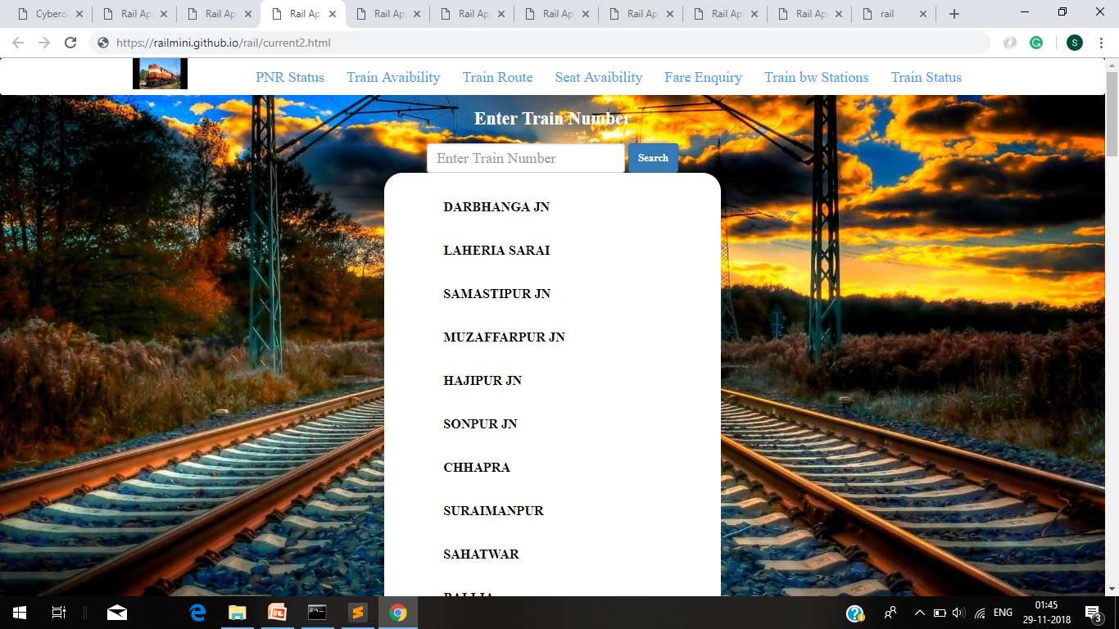

Fig 6.3

Railways are a safe land transport system when compared to other forms of transport. Railway transport is capable of high levels of passenger and cargo utilization and energy efficiency, but is often less flexible and more capital-intensive than road transport, when lower traffic levels are considered .By Train route one can know about all the stations that a train will arrive at just by entering the train number. Vivek Express, named after the name of Saint Swami Vivekananda, is the longest running train across India in terms of time and distance.

Covering over 115,000 kilometer, Indian Railways is one of the largest rail networks in the world. It includes some extraordinarily long routes that span the length and breadth of India. With a running time of 80 hours and 15 minutes and about 55 scheduled stops, the Vivek Express covers the longest train route in India. It originates in northern Assam and goes all the way to the southern tip of India to Kanyakumari.

Seat Availability

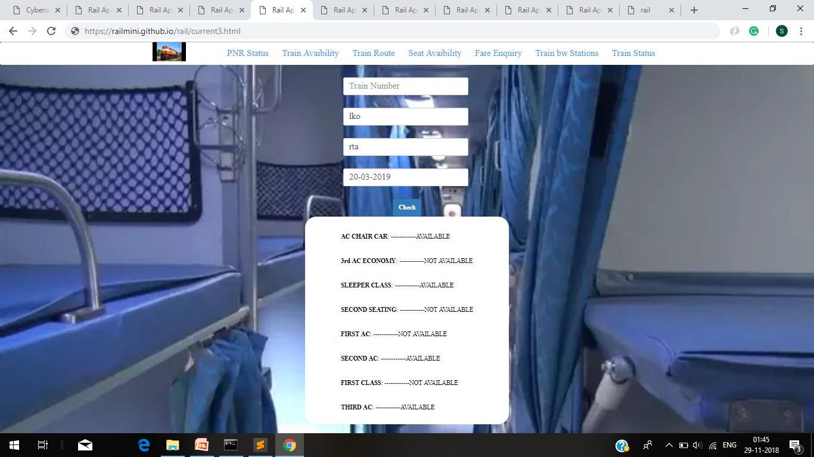

Fig 6.4

A train journey through the scenic terrains of India holds the fancy of most people. Coupled with affordable fares, trains are undoubtedly the prime choice of travel for the majority of Indian population. No wonder then that Indian Railways seat availability is always fraught with stress and confusion. Thankfully, with the advanced reservations of railway tickets for trains opening at least 4 months prior to the journey, most people can now plan their trips well in advance and reserve the best seats in good time. In such a scenario, searching for train seat availability at the last minute is a remote chance in spite of the Tatkal option in place.

So by seat availability one can know about in which class of a train a seat is available just by entering the train number, source station, destination station and date of the journey. Booking tickets on Indian trains is a feat in itself. However, if you are well aware of the seat availability chart, you can easily plan your journey

Fare Enquiry

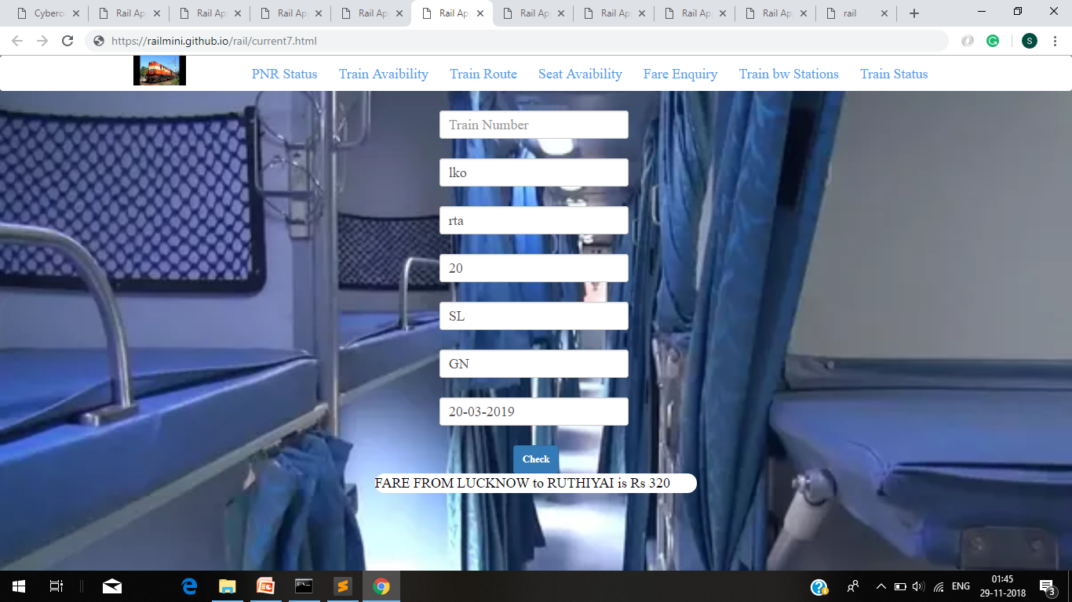

Fig 6.5

A train journey through the scenic terrains of India holds the fancy of most people. Coupled with affordable fares, trains are undoubtedly the prime choice of travel for the majority of Indian population. No wonder then that Indian Railways seat availability is always fraught with stress and confusion.

Thankfully, with the advanced reservations of railway tickets for trains opening at least 4 months prior to the journey, most people can now plan their trips well in advance and reserve the best seats in good time. So we can know the fare of a train by entering the train number, source station, destination station, age, class, quota just at the click of a button. Presently Maharaja Express is the costliest train in India and in the whole world. Many people may be saying that Palace on Wheels is the costliest train in India, but the actual reality is that Maharaja Express run by IRCTC is the costliest.

The others are Palace on wheels, Royal Rajasthan, Deccan Odyssey (2nd costliest), and Golden Chariot. This is among luxurious trains. If you talk about regular costliest train, then its Rajdhani Express trains which connects each state capital to the National capita

Train between Stations

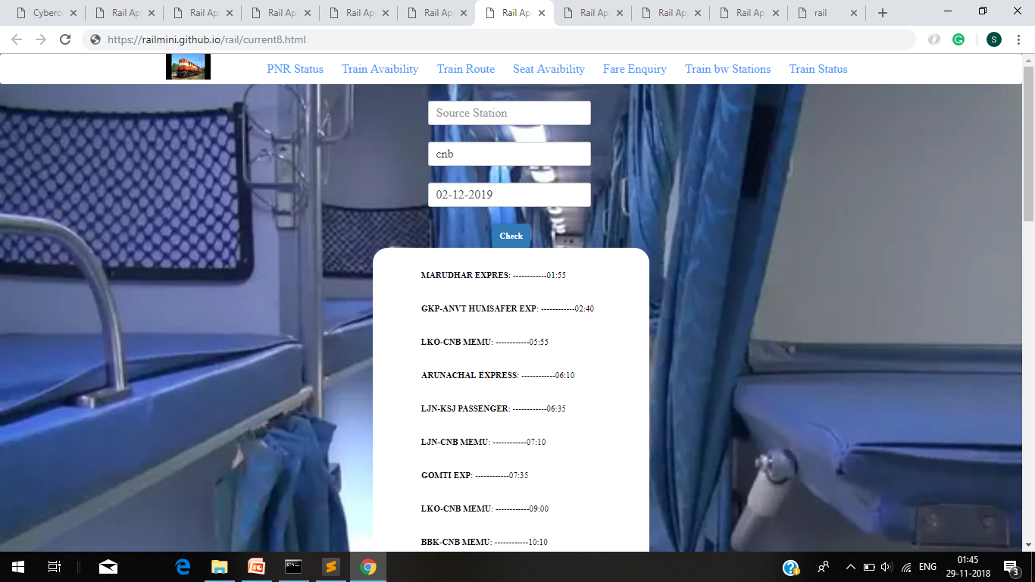

Fig 6.6

One can know the train between two stations just by entering the source station, destination station and date of journey at the click of a button. India railway network covers over 65,000 km and houses more than 7,500 stations across the country. It is one of the largest railway networks in the world, with more than 10,000 passenger trains running between stations every day.

It is necessary to get information on trains between stations, before travelling. The right side form will help you get all the necessary information about trains between stations. Just enter your source city and destination name to get a list of trains connecting the two cities.

For example if one has to book a ticket from Chennai to Sabarimala by train, they can be rest assured of the different stops that come on the way by knowing about the different trains between stations. Due to the large number of trains that are present, it must be important for one to know about the passenger trains between stations that ply on certain days of the week. By doing so, they will be able to exactly plan out their travel itinerary and save up on a lot of money later on.

Live Train Running Status

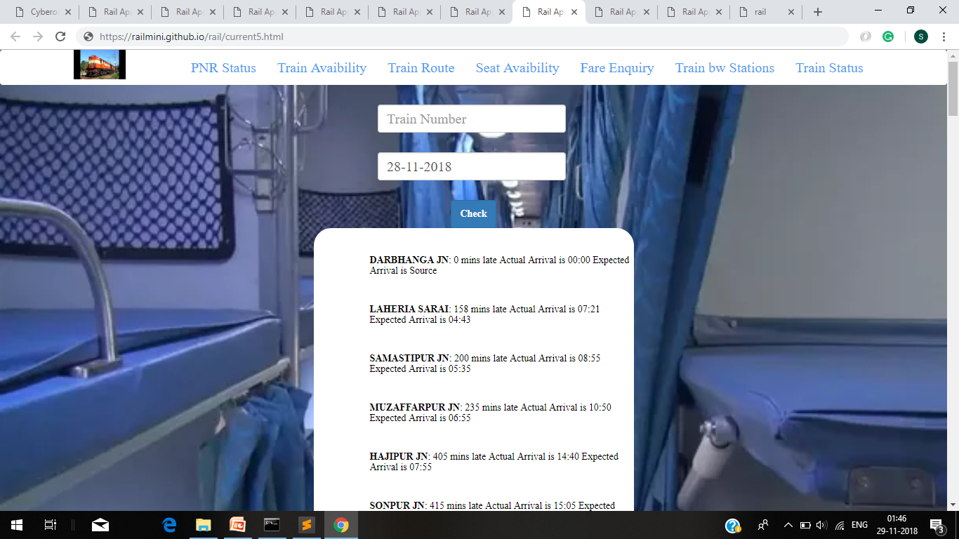

Fig 6.7

One can know about the Live Train Running Status just by entering the train number and date of journey at the click of a button. For Indian railway train running live status means to detect the train’s actual location and its real delay status. Now with various live train status app help us to get to know the actual status of the train. We do not have to call the inquiry again and again. Two important things to notice in the train status app. Last reported location and ETA i.e estimated time of arrival. The two key things which are important to be noted while checking Live Train Status are "Last Reported Location" and "Estimated Time of Arrival (ETA) at upcoming stoppages"

Live train running status for Indian railway trains means the exact location of any train and its real time delay status. It may also include the estimated arrival of the train at any particular station en-route. The last reported station can be either a stoppage or an intermediate station (where the train does not have a regular stoppage and simply is expected to cross the station)

Cancelled Trains

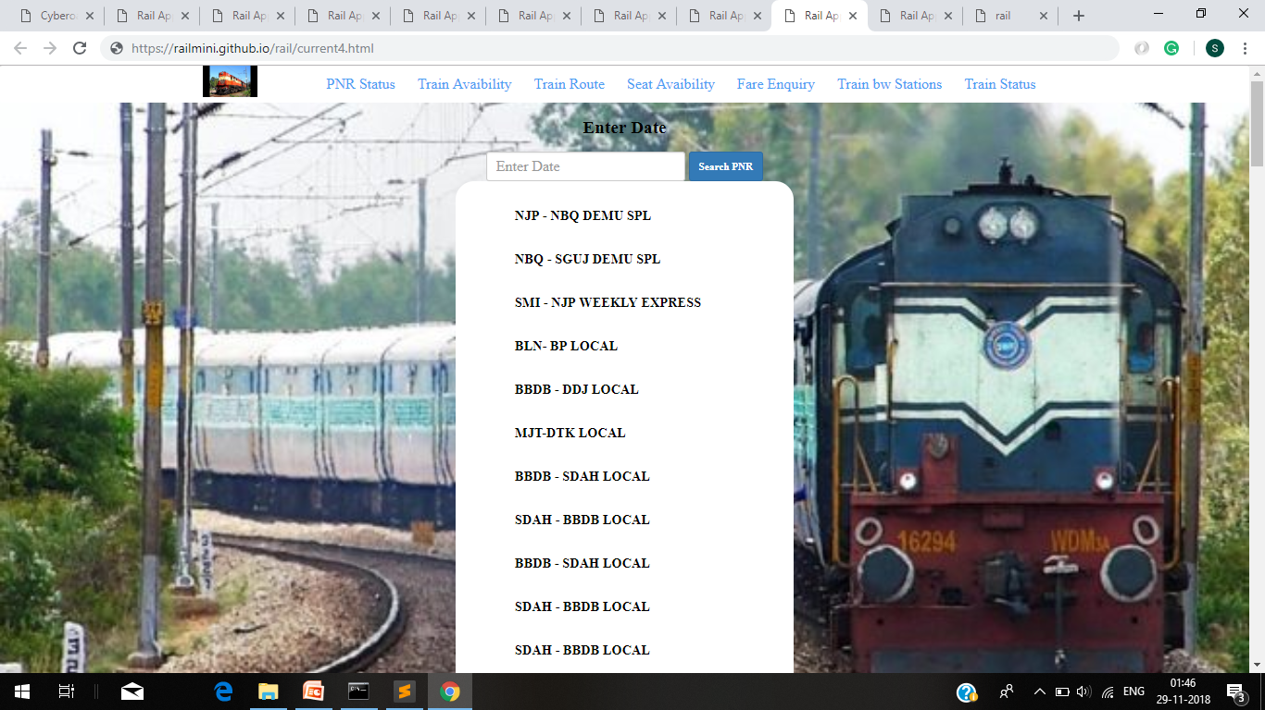

Fig 6.8

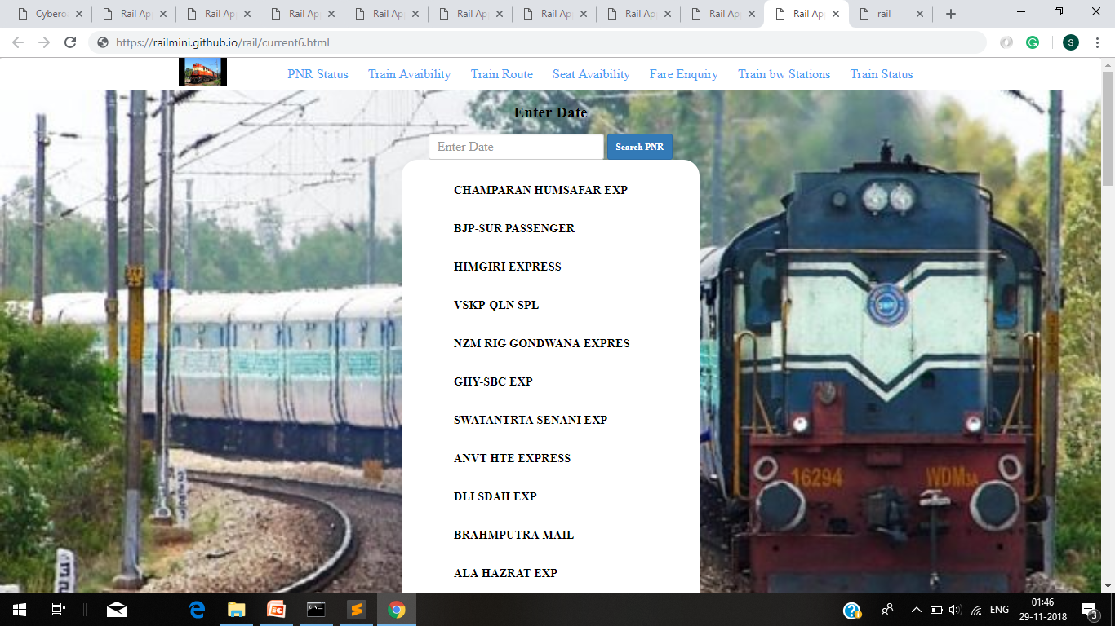We can know about all the trains that have been cancelled or rescheduled just by entering the date at the click of a button.

**Conclusion of the project Railway Enquiry System:**

Our Project in only humble venture to satisfy the needs to manage their project work. Several user friendly coding have also adopted. This package shall prove to be a powerful package in satisfying basic requirements. The objective of software planning is to provide a framework that enables the railway manager to make reasonable estimates made within a limited time frame at the beginning of the software project.

At the end it is concluded that we have made effort on following points…

* A description of the background and context of the project and its relation to work already done in the area.
* Made statement of the aims and objectives of the project.
* The description of Purpose, Scope, and applicability.
* We define the problem on which we are working in project.
* We describe the requirement Specification of the system and the actions that can be done on these things.
* We understand the problem domain and produce a model of the system, which describes operations that can be performed on the system.
* We include features and operations, including screen layouts.
* We designed user interface and security issues related to system.
* Finally the system is implemented and tested according to test cases.

**Limitation of project on Railway Enquiry System**

Although we have put our best efforts to make the software flexible, easy to operate but limitations cannot be ruled out. Though the software presents a broad range of options to its users some intricate options could not be covered into it, partly because of logistic and lack of sophistication. Paucity of time was also major constraint, thus it was not possible to make the software foolproof and dynamic. Lack of time also compelled us to ignore some part such as booking tickets etc.

Considerable efforts have made the software easy to operate even for the people not related to the field of computers but it is acknowledged that users may find it a bit problematic at the first instance. The user is provided help at each step for his convenience in working with software.

**Future Scope of the project:**

In a nutshell, it can be summarized that the future scope of the project circles around maintaining information regarding:

* We can add login credentials to book the tickets.
* We can add printer in future.
* We can give more advance software for Railway Enquiry System including more facilities.
* Integrate multiple load balancers to distribute the loads of the system.

The above mentioned points are enhancements that can be done to increase the applicability and usage of this project. Here we can get records of train like running status, seat availability, Train route, etc. Enhancements can be done to maintain all the Train routes, Train status, Train Enquiry, etc.

We have all the options open so that if there is any other future requirement in the system by the user for the enhancement of the system then it is possible to implement them. In the last we would like to thank all the persons involved in the development of the system directly or indirectly. We hope that the project will serve its purpose for which it is developed there by underlining success of process.

**References and bibliography:**

* [www.google.com](http://www.google.com)/ for problem solving.
* [www.tutorialspoint.com](http://www.tutorialspoint.com)/ for front end part help.
* [www.stackoverflow.com](http://www.stackoverflow.com)/ for more references.
* <https://github.com/> for hosting the project online.
* <https://railwayapi.com/> for fetching backend data from other server.
* [www.w3school.com](http://www.w3school.com)/ for coding part help.

********